

Programme Name: ________**BCS HONS**_______________________________________

Course Code: __**CSC 2516**________

Course Name: _______**Data Structure and Algorithm**_____________________________

Assignment/ Lab Sheet / **Project** / Case Study No. _**1**___

Date of Submission: ______**8/31/2021**_____________

**Submitted By: Submitted To:**

Student Name**: Dipesh Tha Shrestha** Faculty Name**: Prakash Chandra Sir**

IUKL ID: **041902900028** Department**: LMS**

Semester**: Fourth Semester**

Intake**: September 2019**

**PROJECT TITLE: STUDENT RECORD MANAGEMENT SYSTEM FOR COLLEGE**

**Abstract**

Our project explains about the student management. This project mainly explains the various actions related to student details. The student Record System is based on the concept of managing student records. There’s a login system available for this system, the user can freely use its feature. This mini project contains limited features, but the essential one. This project is helpful for managing student information by adding, updating, removing, viewing, and searching for details.

**INTRODUCTION - STUDENT RECORD MANAGEMENT SYSTEM**

Student Record Management System is software which is helpful for students as well as the school authorities. In the current system all the activities are done manually. It is very time consuming and costly. Our Student Management System deals with the various activities related to the students

**Features**

Talking about the features of this Simple system, the user can perform the CRUD operations to it. Like, add student details by entering his/her name, roll number, GPA, Course ID, name, etc. The user can also view all the available student records. Besides, the user can edit information as well as remove a student’s whole data. The system creates an external file to store the user’s data permanently. This system is developed using C Programming Language and different variables, strings have been used for the development of it.

**Testing**

As you see, there are 5 option.

* 1 is to insert student details,
* 2 is to search student details,
* 3 is to delete the student detail,
* 4 is to update or change student detail and
* 5 is to display all student detail.
* **When you select option 1, we put the information of the student such as roll number, name, phone number and your marks**.

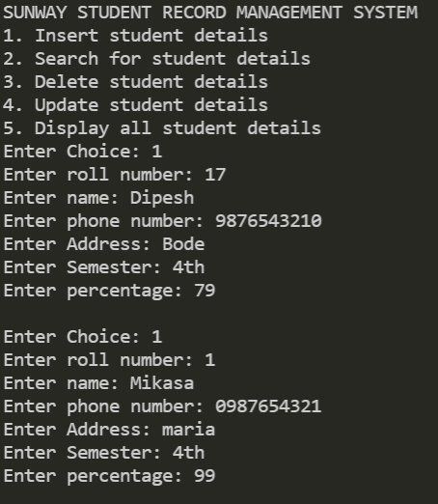

* **Option 2 help you to find student detail with your roll number**.

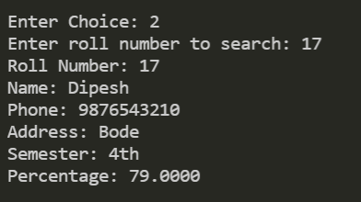

* **Option 5 help to display all the detail of student which have been recorded or inserted**.

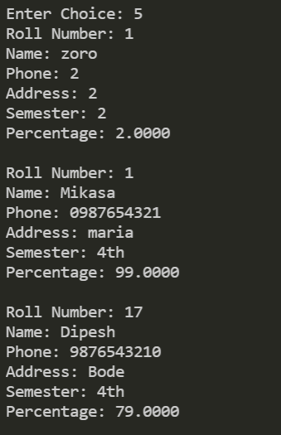

* **Option 3 helps you to delete the student record by its roll number, as you can see roll no 1(zoro) have been deleted from the record**

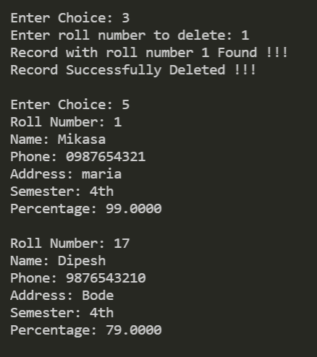

* **Option 4 help to change or modify the student information.**

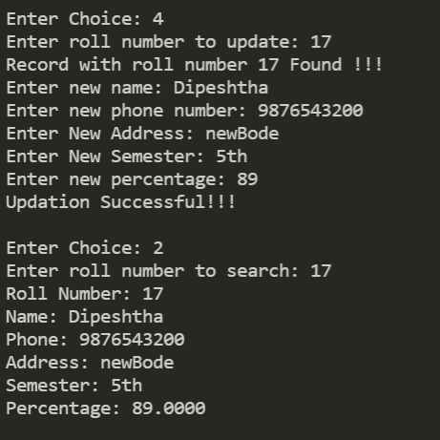

**Appendix**

#include<stdlib.h>

#include<string.h>

#include<stdio.h>

*struct* Student

{

*int* rollnumber;

*char* name[100];

*char* phone[100];

*char* address[100];

*char* semester[100];

*float* percentage;

*struct* Student *next;

}* head;

*void* insert(*int* *rollnumber*, *char*\* *name*, *char*\* *phone*, *char*\* *address*, *char*\* *semester*, *float* *percentage*)

{

*struct* Student * student = (*struct* Student *) malloc(sizeof(*struct* Student));

    student->rollnumber = *rollnumber*;

    strcpy(student->name, *name*);

    strcpy(student->phone, *phone*);

    strcpy(student->address, *address*);

    strcpy(student->semester, *semester*);

    student->percentage = *percentage*;

    student->next = NULL;

    if(head==NULL){

        // if head is NULL

        // set student as the new head

        head = student;

    }

    else{

        // if list is not empty

        // insert student in beginning of head

        student->next = head;

        head = student;

    }

}

*void* search(*int* *rollnumber*)

{

*struct* Student * temp = head;

    while(temp!=NULL){

        if(temp->rollnumber==*rollnumber*){

            printf("Roll Number: %d\n", temp->rollnumber);

            printf("Name: %s\n", temp->name);

            printf("Phone: %s\n", temp->phone);

            printf("Address: %s\n", temp->address);

            printf("Semester: %s\n", temp->semester);

            printf("Percentage: %0.4f\n", temp->percentage);

            return;

        }

        temp = temp->next;

    }

    printf("Student with roll number %d is not found !!!\n", *rollnumber*);

}

*void* update(*int* *rollnumber*)

{

*struct* Student * temp = head;

    while(temp!=NULL){

        if(temp->rollnumber==*rollnumber*){

            printf("Record with roll number %d Found !!!\n", *rollnumber*);

            printf("Enter new name: ");

            scanf("%s", temp->name);

            printf("Enter new phone number: ");

            scanf("%s", temp->phone);

            printf("Enter New Address: ");

            scanf("%s", temp->address);

            printf("Enter New Semester: ");

            scanf("%s", temp->semester);

            printf("Enter new percentage: ");

            scanf("%f",&temp->percentage);

            printf("Updation Successful!!!\n");

            return;

        }

        temp = temp->next;

    }

    printf("Student with roll number %d is not found !!!\n", *rollnumber*);

}

*void* Delete(*int* *rollnumber*)

{

*struct* Student * temp1 = head;

*struct* Student * temp2 = head;

    while(temp1!=NULL){

        if(temp1->rollnumber==*rollnumber*){

            printf("Record with roll number %d Found !!!\n", *rollnumber*);

            if(temp1==temp2){

                // this condition will run if

                // the record that we need to delete is the first node

                // of the linked list

                head = head->next;

                free(temp1);

            }

            else{

                // temp1 is the node we need to delete

                // temp2 is the node previous to temp1

                temp2->next = temp1->next;

                free(temp1);

            }

            printf("Record Successfully Deleted !!!\n");

            return;

        }

        temp2 = temp1;

        temp1 = temp1->next;

    }

    printf("Student with roll number %d is not found !!!\n", *rollnumber*);

}

*void* display()

{

*struct* Student * temp = head;

    while(temp!=NULL){

        printf("Roll Number: %d\n", temp->rollnumber);

        printf("Name: %s\n", temp->name);

        printf("Phone: %s\n", temp->phone);

        printf("Address: %s\n", temp->address);

        printf("Semester: %s\n", temp->semester);

        printf("Percentage: %0.4f\n\n", temp->percentage);

        temp = temp->next;

    }

}

*int* main()

{

    head = NULL;

*int* choice;

*char* name[100];

*char* phone[100];

*char* address[100];

*char* semester[100];

*int* rollnumber;

*float* percentage;

    printf("SUNWAY STUDENT RECORD MANAGEMENT SYSTEM\n1. Insert student details\n2. Search for student details\n3. Delete student details\n4. Update student details\n5. Display all student details");

    do

    {

        printf("\nEnter Choice: ");

        scanf("%d", &choice);

        switch (choice)

        {

            case 1:

                printf("Enter roll number: ");

                scanf("%d", &rollnumber);

                printf("Enter name: ");

                scanf("%s", name);

                printf("Enter phone number: ");

                scanf("%s", phone);

                printf("Enter Address: ");

                scanf("%s", address);

                printf("Enter Semester: ");

                scanf("%s", semester);

                printf("Enter percentage: ");

                scanf("%f", &percentage);

                insert(rollnumber, name, phone, address, semester, percentage);

                break;

            case 2:

                printf("Enter roll number to search: ");

                scanf("%d", &rollnumber);

                search(rollnumber);

                break;

            case 3:

                printf("Enter roll number to delete: ");

                scanf("%d", &rollnumber);

                Delete(rollnumber);

                break;

            case 4:

                printf("Enter roll number to update: ");

                scanf("%d", &rollnumber);

                update(rollnumber);

                break;

            case 5:

                display();

                break;

        }

    } while (choice != 0);

}

**Output:**

**When you run the code**

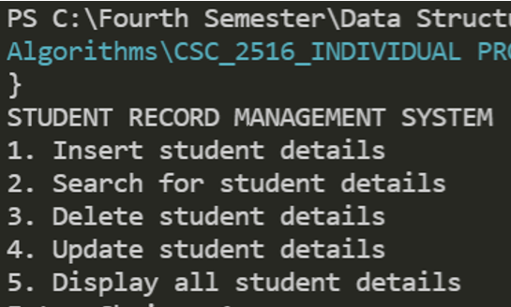

**Thank You**